2016 BEEKEEPERS SHORT
COURSE
Mon County Beekeepers Association
The Mon County Beekeepers have scheduled a short course for beginners and anyone wanting to know more about honeybees. Classroom session on April 9th will be at the WVU County Extension Service Office in Westover, WV. WestMon Plaza from 9:30am – 1:00pm
WVU Extension Service
Monongalia County Office
34 Commerce Drive, Suite 106
Morgantown, WV 26501

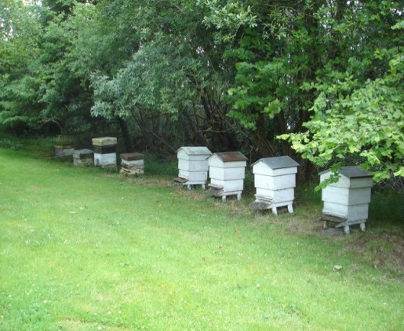
Class registration is $40.00 which includes one year membership in the local Mon. Co. Beekeepers Association and the State WV Beekeeping Association and also a book titled ‘Homegrown Honey Bees an Absolute Beginner’s Guide’. Fee will be due at first session. Class size is limited. Register early.

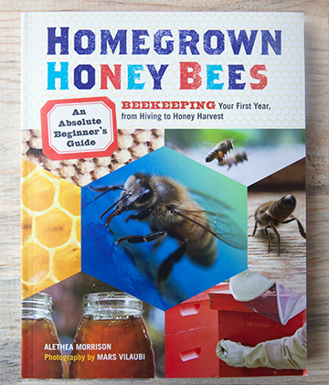

TOPICS INCLUDE
- Why Bees?
- Bee Life 101
- Getting Started
- Equipment
- Thru the Seasons

For more information you can call WVU Mon. Co.
Extension Service or Mark @ 304-296-4158 or
you can email us at mcmbecfam@yahoo.com.
Some catalogs available for bee supplies include:
Walter T. Kelley Co.
Mann Lake Ltd. Beekeeping
Brushy Mountain
Dadant & Sons
Better Bee

There are also publications for beekeeping which include:
Bee Culture (monthly magazine)
The American Bee Journal (monthly magazine)
ABC XYZ Of Beekeeping (book)
The Hive and the Honeybee (book)

There is West Virginia Honey Producers located in Weston, WV that carries supplies and often provides package bees.

MONONGALIA COUNTY
BEEKEEPERS ASSOCIATION
IS NOW OFFERING
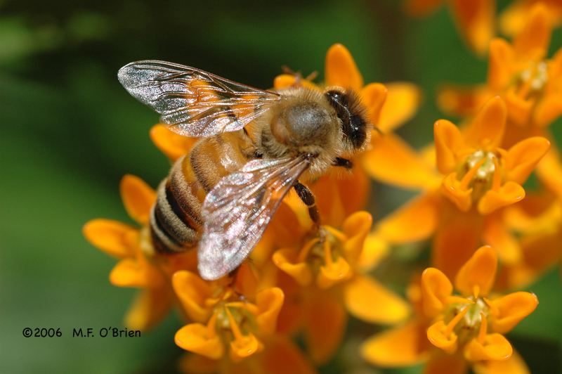
2016 BEGINNER SPRING CLASSES
STARTING APRIL 9TH
^{Visit us @ moncobkr.com}

